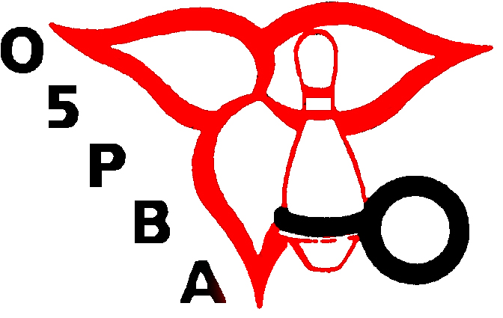
ONTARIO 5 PIN BOWLERS’ ASSOCIATION

TOURNAMENT DIRECTORS RECERTIFICATION REQUEST FORM

Please complete this Tournament Directors Recertification Request Form and return to the O5PBA together with a cheque or money order for $25.00 made payable to the “ONTARIO 5 PIN BOWLERS’ ASSOCIATION”

____________________________________________________________________________________
Name

____________________________________________________________________________________
Address

____________________________________________________________________________________
City/Town

_______________________
Postal Code

(_______)___________________
Phone Number

__________________________________________________________________________________
Zone/DC Association

__________________________________________________________________________________
Position (If any)

________________________________________________ __________________________
Signature Date

ONTARIO 5 PIN BOWLERS’ ASSOCIATION - 3 Concorde Gate, Suite 302, Toronto, Ontario M3C 3N7
Telephone: (416) 426-7167 Fax: (416) 426-7364 Website: www.o5pba.ca

